Prof. Besser

CST 238 – GUI

Nicholas Slaughter

April 27, 2018

Measuring The Distance An Electric Car Can Go: GUI

Person Interviewed: Lucas Cordova (Lucas.Cordova@oit.edu)

On April 24th I interviewed Professor Lucas Cordova and asked him what problem he would like solved with the use of a mobile application. His response was that of making a GUI that would tell him how far he could drive his electric car before running out of battery and gas (His car has a reserve gas tank for when the battery dies).

The Problem:

Professor Cordova says that he frequently worries about how far he can drive his car without running out of fuel because there is no good indicator on how far he can go. He also stated that there are apps that will generate how far he can go with his remaining battery life, but they do not take into account his reserve tank. This results in the other applications being un-useful to him.

The Solution:

After we had talked about what he wants from this app we came up with a few requirements that he wants in the application. These requirements are as follows: An easy to use interface, something that tells him how far he can go, a map with the radius representing how far he can go, the ability to add a destination to see if he can make it, as well as information telling him how much further he can go once reaching his destination. Once we finished identifying the requirements I began drawing some prototype screens to see what he wanted visually. The designs below are the screens he ended up picking as the best visual representations of what he wanted. These GUIs solve Professor Cordova’s Problem by calculating how far you can go with regards to the battery life and the amount of gas left in your tank.

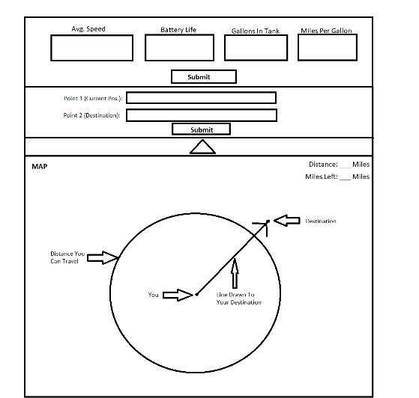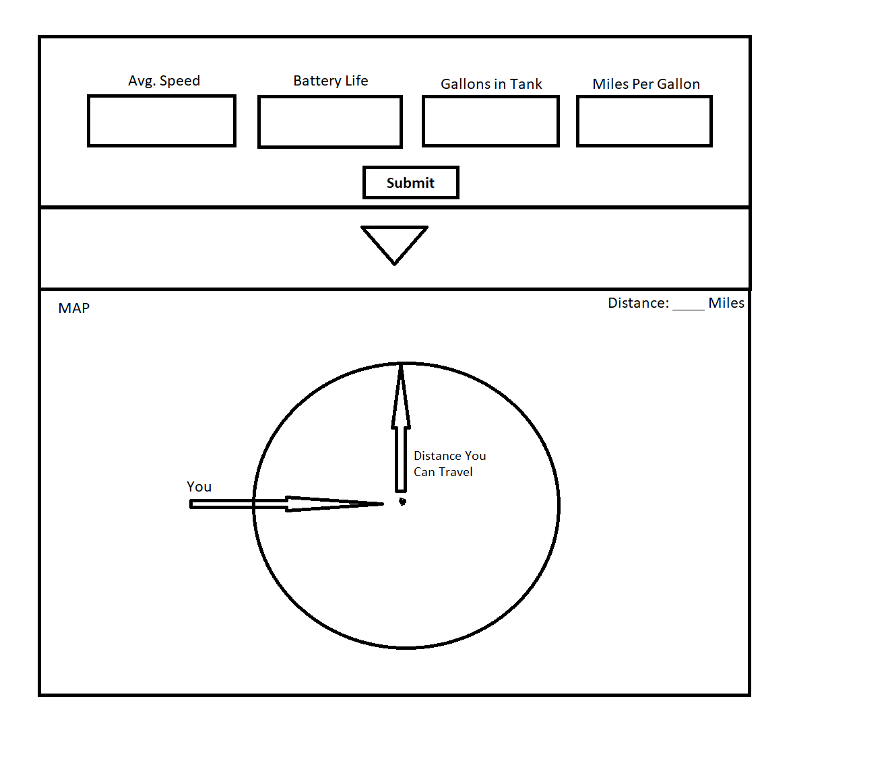

GUI Without Destination

GUI With Destination

Story Board:

GUI Without Destination:

1. Enter Constants
2. Hit The Submit Button
3. 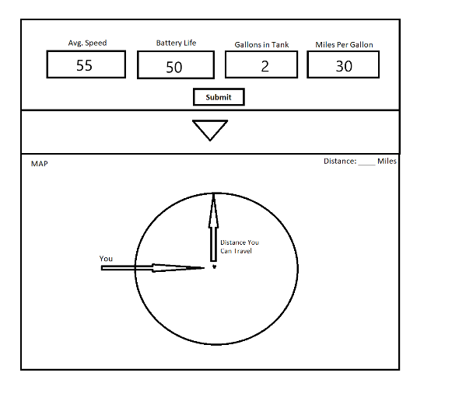View Map To See How Far You Can Go

Step 1

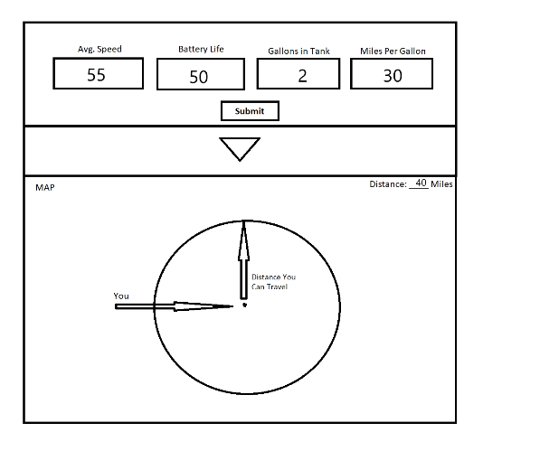

Step 3

GUI With Destination:

1. Enter Constants
2. Click The Drop Down Menu
3. Enter Point 1 (Will Default To Current Position)
4. Enter Point 2 (Destination)
5. Hit The Submit Button
6. View Map To See If You Can Reach Your Destination

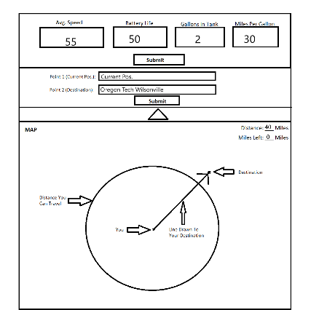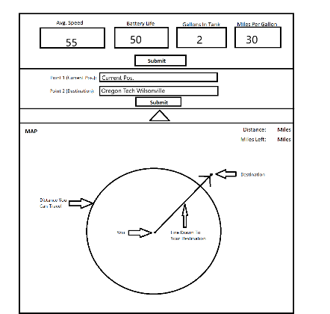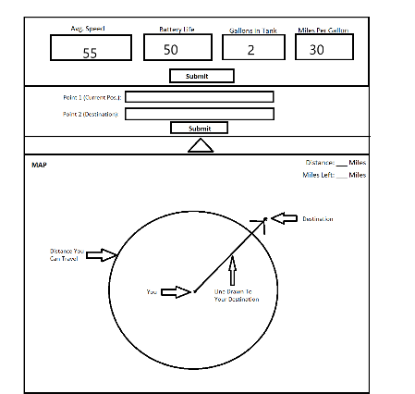

Step 6

Step 3 & 4

Step 1 & 2